

**COPYRIGHT AGREEMENT**

Please complete and sign the form and send it with the final version of your manuscript. It is required to obtain written confirmation from authors in order to acquire copyrights for papers published in the journal so as to index them to various repositories.

**Paper ID:- IJISRT25MAR351**

**Title of Paper:- Comparative Analysis of Data Driven Techniques to Predict Transfer Prices of Football Players**

**Author(s):**

|  |  |
| --- | --- |
| **1. Vedant Bhawnani** | **2. Shubh Harde** |
| **3. Shruti Savant** |  |
|  |  |
|  |  |
|  |  |

The undersigned hereby transfer any and all rights in and to the paper including without limitation all copyrights to the IJISRT. The undersigned hereby represents and warrants that the paper is original and that he/she is the author of the paper, except for material that is clearly identified as to its original source, with permission notices from the copyright owners where required. The undersigned represents that he/she has the power and authority to make and execute this assignment.

This agreement is to be signed by at least one of the authors who have obtained the assent of the co-author(s) where applicable. (Sign it with pen after printout or Add picture of the signature)

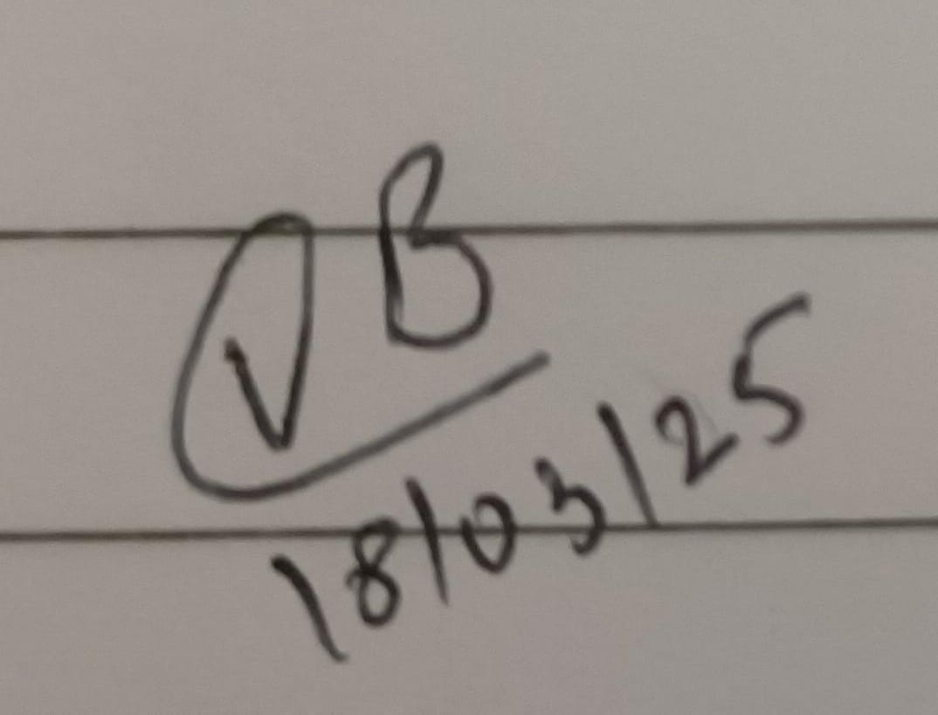

**Author's Signature & Date**

Vedant Bhawnani

**Author's Name**

Dwarkadas J. Sanghvi College of Engineering

**Institution or Company**

**Submit through your IJISRT account, Read FAQ 4. for it;** [**https://ijisrt.com/faq**](https://ijisrt.com/faq)